|  |  |
| --- | --- |
|  | **DEPARTMENT OF COMPUTER SYSTEMS ENGINEERING**  **MEHRAN UNIVERSITY OF ENGINEERING & TECHNOLOGY, JAMSHORO**  **Database Management Systems (4th Semester) 18CS**  **Lab Experiment 13** |

|  |  |  |  |
| --- | --- | --- | --- |
| **Roll No:** |  | **Date of Conduct:** |  |
| **Submission Date:** |  | **Grade Obtained:** |  |

|  |  |  |  |
| --- | --- | --- | --- |
| **Problem Recognition (0.3)** | **Completeness & accuracy (0.4)** | **Timeliness (0.3)** | **Score (1.0)** |
|  |  |  |  |

**Objective: To create and use Cursors in PL/SQL**

**Tools: MYSQL** Oracle.

**Introduction:**

**Cursors** : A **cursor** is a pointer to this context area. PL/SQL controls the context area through a cursor. A cursor holds the rows (one or more) returned by a SQL statement. The set of rows the cursor holds is referred to as the **active set**.

You can name a cursor so that it could be referred to in a program to fetch and process the rows returned by the SQL statement, one at a time. There are two types of cursors.

* Implicit cursors
* Explicit cursors

**Implicit cursors**: Whenever Oracle executes an SQL statement such as [SELECT INTO](https://www.oracletutorial.com/plsql-tutorial/plsql-select-into/), [INSERT](https://www.oracletutorial.com/oracle-basics/oracle-insert-into-select/), [UPDATE](https://www.oracletutorial.com/oracle-basics/oracle-update/), and [DELETE](https://www.oracletutorial.com/oracle-basics/oracle-delete/), it automatically creates an implicit cursor.

Oracle internally manages the whole execution cycle of implicit cursors and reveals only the cursor’s information and statuses such as SQL%ROWCOUNT, SQL%ISOPEN, SQL%FOUND, and SQL%NOTFOUND.

The implicit cursor is not elegant when the query returns zero or multiple rows which cause NO_DATA_FOUND or TOO_MANY_ROWS exception respectively.

**Explicit cursors**: An explicit cursor is an [SELECT](https://www.oracletutorial.com/oracle-basics/oracle-select/) statement declared explicitly in the declaration section of the current block or a package specification.

For an explicit cursor, you have control over its execution cycle from OPEN, FETCH, and CLOSE.

Oracle defines an execution cycle that executes an SQL statement and associates a cursor with it. The following illustration shows the execution cycle of an explicit cursor

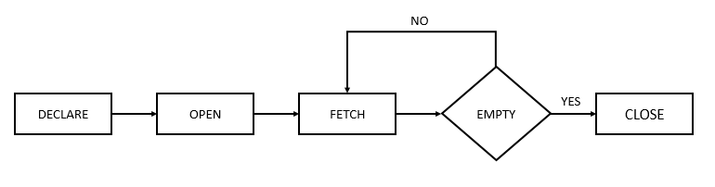

### **Explicit Cursor Attributes:**

A cursor has four attributes to which you can reference in the following format: cursor_name%attribute (where cursor_name is the name of the explicit cursor)

1. **%ISOPEN:**

This attribute is TRUE if the cursor is open or FALSE if it is not.

1. **%FOUND:**

This attribute has four values:

* NULL before the first fetch
* TRUE if a record was fetched successfully
* FALSE if no row returned
* INVALID_CURSOR if the cursor is not opened

1. **%NOTFOUND:**

This attribute has four values:

* NULL before the first fetch
* FALSE if a record was fetched successfully
* TRUE if no row returned
* INVALID_CURSOR if the cursor is not opened

1. **%ROWCOUNT:**

The %ROWCOUNT attribute returns the number of rows fetched from the cursor. If the cursor is not opened, this attribute returns INVALID_CURSOR.

**Lab Task**

1. **Write a program in PL/SQL to find the number of rows effected using SQL%ROWCOUNT attributes of an implicit cursor.**

**Task:**

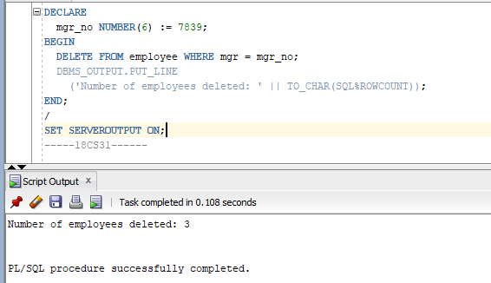

1. **Write a program in PL/SQL to display detail information for the employee of ID 7839 from the employees’ table.**

**Task:**

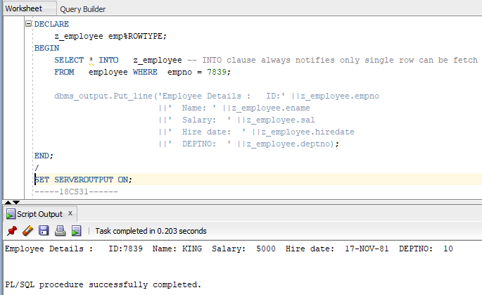

1. **Write a program in PL/SQL to display detail information of all employees from employees table using explicit cursor.**

**Task:**

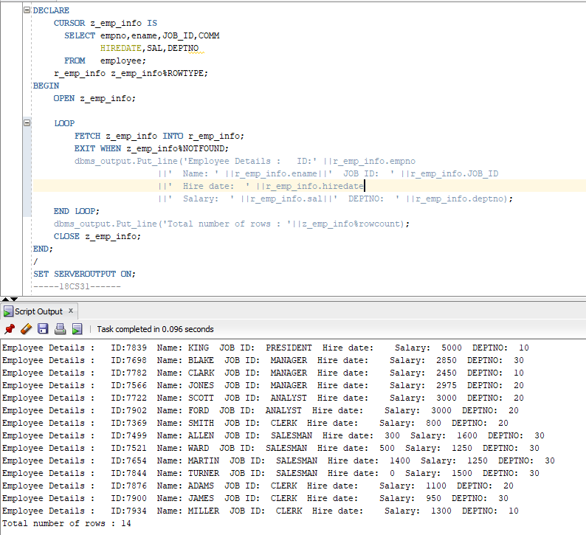

1. **Write a PL/SQL block that uses explicit cursors to retrieve employees one by one and displays the name and salary of those employees currently working in deptno 30.**

**Task:**

